The HIVE’s KY Gives Day DONATION LINK:
https://www.kygives.org/organizations/the-hive-habilitation-information-vocation-education-inc
BEFORE MAY 12
I’m supporting The HIVE this Kentucky Gives Day (May 12) because every adult deserves a place to belong. 💛
After high school, opportunities for adults with intellectual and developmental disabilities can become very limited—but that’s where The HIVE steps in.
At their Bowling Green and Scottsville locations, they’re creating a community where people can build confidence, learn life skills, and form real friendships.
I care about this because __________________________.
Bookmark their donations page and join me in supporting The HIVE on May 12!
https://www.kygives.org/organizations/the-hive-habilitation-information-vocation-education-inc
#KYGives26 #TheHIVE #CommunityForAll

Kentucky Gives Day is almost here! 🎉 (May 12)
I’ll be supporting The HIVE, a local organization that provides meaningful programs and community for adults with intellectual and developmental disabilities.
They believe everyone deserves dignity, opportunity, and belonging—and I couldn’t agree more.
If you’re looking for a way to make a real impact, this is it.
I’m giving because __________________________.
Will you join me? Bookmark The HIVE’s donation page: https://www.kygives.org/organizations/the-hive-habilitation-information-vocation-education-inc
#KYGives26 #GiveLocal #TheHIVE
For PARENTS / CAREGIVERS
Pre-Event:
As a parent/caregiver, finding meaningful opportunities for adults with disabilities after high school isn’t easy.
That’s why The HIVE means so much to my family. 💛
At The HIVE, adults can build independence, make friends, and truly feel like they belong. And families like ours get the support they need.
For us, The HIVE has meant __________________________.
On May 12, I’ll be supporting The HIVE for Kentucky Gives Day. I hope you’ll consider joining me.
#KYGives26 #TheHIVE #InclusionMatters

On May 12:
Today is Kentucky Gives Day!
I’m giving to The HIVE because I’ve seen firsthand the difference it makes.
__________________________ (share a moment, impact, or change you’ve seen)
The HIVE creates a space where adults with disabilities can grow, connect, and be part of a community that values them.
If you’re able, please consider supporting this incredible organization today: https://www.kygives.org/organizations/the-hive-habilitation-information-vocation-education-inc
#KYGives26 #SupportTheHIVE

For HIVE MEMBERS:
On May 12:
Today is Kentucky Gives Day! 🎉
The HIVE is important to me because __________________________.
I have made friends and learned __________________________.
Please help support The HIVE today: https://www.kygives.org/organizations/the-hive-habilitation-information-vocation-education-inc
Thank you! 💛
#KYGives26 #TheHIVE

For STAFF:
Pre-Event:
I’m proud to be part of The HIVE team. 💛
Every day, I get to see adults with intellectual and developmental disabilities build confidence, learn new skills, and form meaningful friendships.
Moments like __________________________ are why this work matters so much to me.
On May 12, I’ll be supporting The HIVE for Kentucky Gives Day. If you’re looking for a way to make a real impact in our community, I hope you’ll join me.
#KYGives26 #TheHIVE #PurposeDrivenWork
On May 12:
Today is Kentucky Gives Day! 🎉
Working at The HIVE, I see firsthand the impact of a community built on belonging.
__________________________ (share a moment—big or small—that stuck with you)
Your support helps make these moments possible—providing programs, connection, and opportunities for adults with intellectual and developmental disabilities.
If you’re able, please consider giving today: https://www.kygives.org/organizations/the-hive-habilitation-information-vocation-education-inc
Thank you for supporting this work. 💛
#KYGives26 #TheHIVE #CommunityMatters

For BOARD:
Pre-Event:
I’m proud to serve on the Board of The HIVE, an organization creating meaningful opportunities for adults with intellectual and developmental disabilities in the Barren River region.
The transition out of school services leaves too many individuals without options—but that’s when The HIVE steps in.
Through its Clubhouse model, The HIVE has created a community centered on growth, independence, and belonging.
On May 12, I’ll be supporting this important work for Kentucky Gives Day. I invite you to join me.
__________________________ (optional personal note)
#KYGives26 #TheHIVE #CommunityLeadership
On May 12:
Today is Kentucky Gives Day, and I’m asking you to join me in supporting The HIVE.
As a board member, I’ve seen the impact of this organization—providing life skills programming, social connection, and a true sense of belonging for nearly 200 adults with intellectual and developmental disabilities and their families each year.
This work matters, and it is only possible because of community support.
Please consider making a gift today: https://www.kygives.org/organizations/the-hive-habilitation-information-vocation-education-inc
Thank you for helping build a more inclusive community.
#KYGives26 #GiveLocal #TheHIVE
IMAGES:
To use one of these images, right click, then choose “Save as Picture,” save the image to your device, then upload to FB or Instagram as you would any other picture.
LOGO:
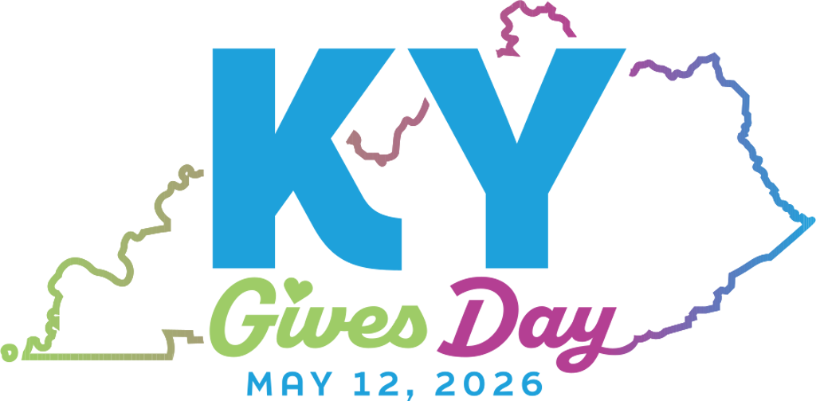
Facebook Post:
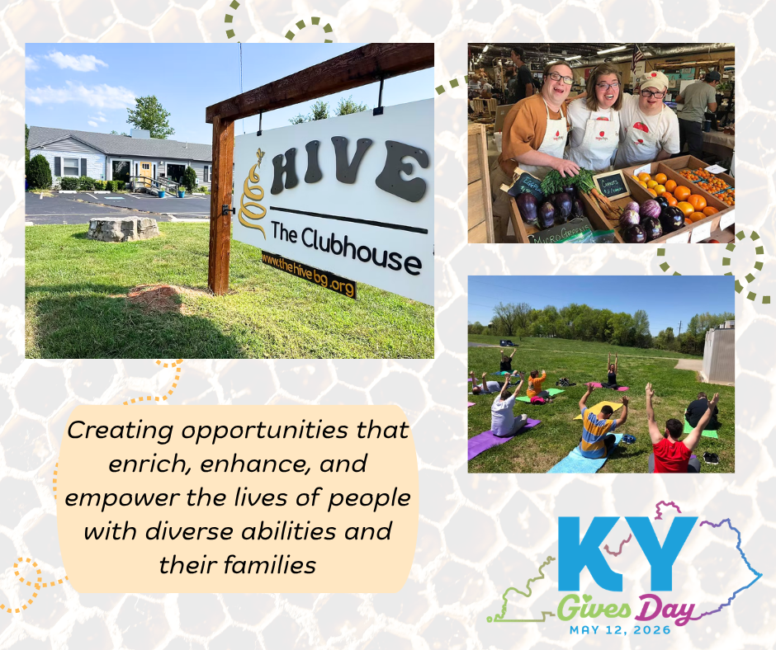

Instagram Post:
